# СуперExercise: Responsive Web Design

Problems for exercises and homework for the ["HTML and CSS" course @ SoftUni](https://softuni.bg/courses/html-and-css).

## Responsive Site Layout

Create the following layout and make it responsive by using media query to change the flex container behavior.

The Web page should look like the following:

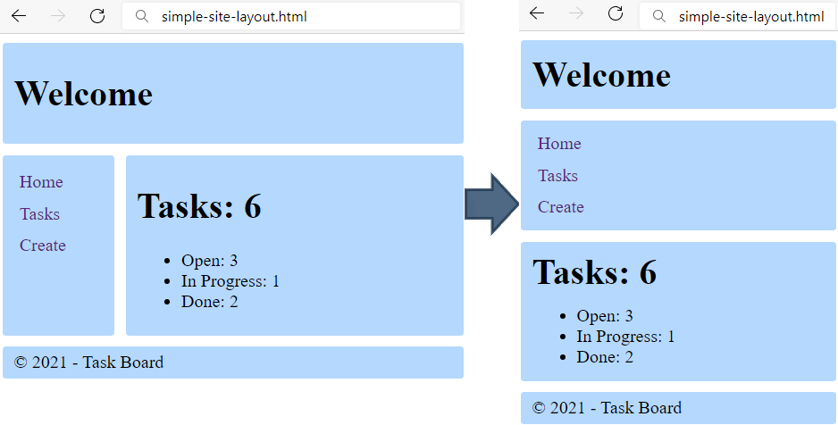

## Hints

* Make the body element flex container.
* Make the header element flex container, align the elements center vertically.
* Change the body element flex direction to column when the screen is smaller than 500px.

## Responsive Top Menu

Add to the previous solution navigation and make it responsive by using media query.

The web page should look like the following screenshot:

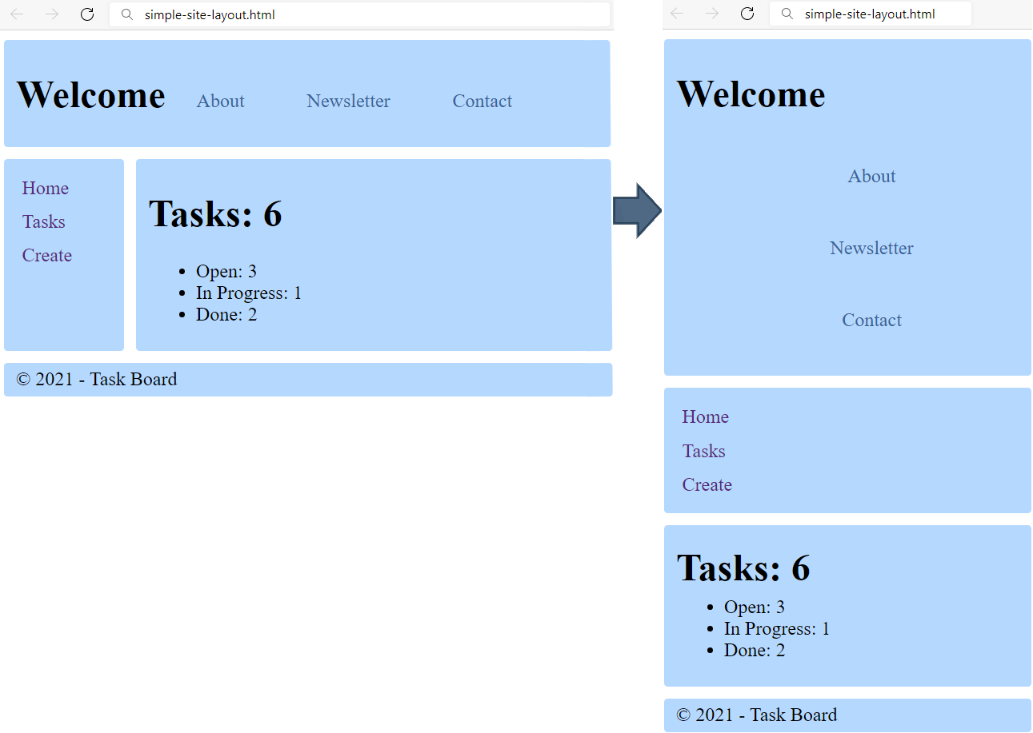

### Requirements

Add in the header:

* <nav>tag with:
* <ul> tag for unordered list
* <li> tag for list item
* <a> tag for hyperlink

Make the navigation responsive by using media query. Define a maximum width of 500px, if the screen is less than that:

* the <a> tag in the <nav> need to be displayed as block and with padding-left: 5px
* the <ul> tag in the <nav> need to be left with **0** margin and padding

## Media Queries in Typography

Upgrade your typograpgy.css file from previous homework’s with Media Queries. Create the following page for different screen sizes:

|  |  |  |  |
| --- | --- | --- | --- |
| Desktop | Laptop | Tablet | Phone |
|  |  |  |  |

### Requirements

* Change the document **title** to "**Media Queries in Typography"**
* Make the font size for **phones** 12px
* Make the font size for screens **larger** than 500 14px
* Make the font size for screens **larger** than 600 16px
* Make the font size for screens **larger** than 800 18px
* Make the font size for screens **larger** than 1300 21px
* Make the font size for screens **larger** than 1800 23px

## Responsive Media Boxes

Create a web page like the following:

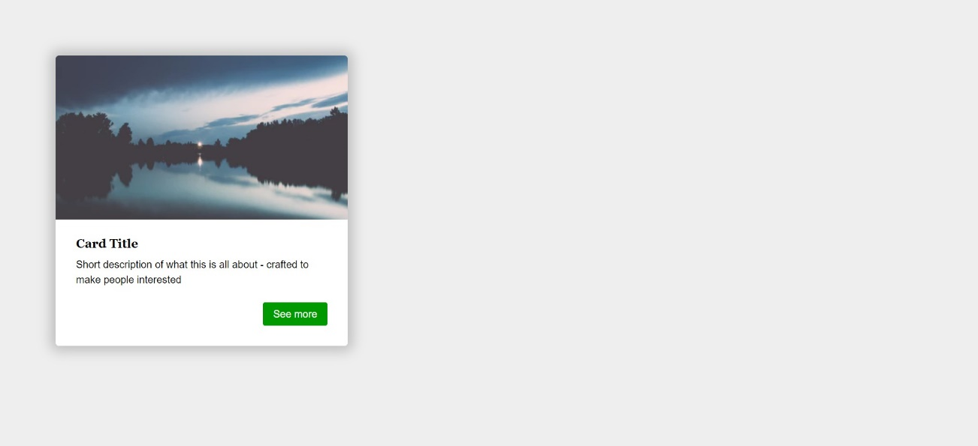

### Requirements

* Change the document title to "**Responsive Media Boxes**"
* Create a section with two div elements
* You can access the image [here](https://images.unsplash.com/photo-1538230942844-e89414a0692d?ixlib=rb-0.3.5&ixid=eyJhcHBfaWQiOjEyMDd9&s=34dcc54db235ce71b59c1d5ada02bdc4&auto=format&fit=crop&w=400&q=80)
* Use rgb(238, 238, 238) for body background
* Use rgb(255, 255, 255) for card background
* Use rgb(0, 153, 0) for card button background
* Use font Georgia, serif with size 1em/1.2 for the headings
* Use font Helvetica, sans-serif for the document

## Landing Page

Create a web page like the following:

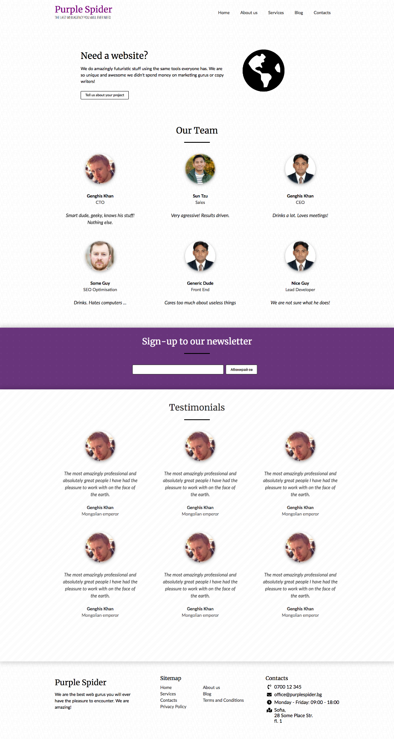

* Look at the provided screenshots in **resources** **folder** for different screen size’s view

### Requirements

* Change the document title to "**Landing Page**"
* Get the latest reset.css
* Get the latest typography.css
* Get the latest buttons.css
* Get the latest forms.css
* Create a section with a title Need a website?
* Create a section with a title Our Team
* Create a section with a title Sign-up to our Newsletter
* Create a section with a title Testimonials
* Create a footer
* Make the page **responsive** per the screenshots attached

## Responsive Tables

Create a web page like the following:

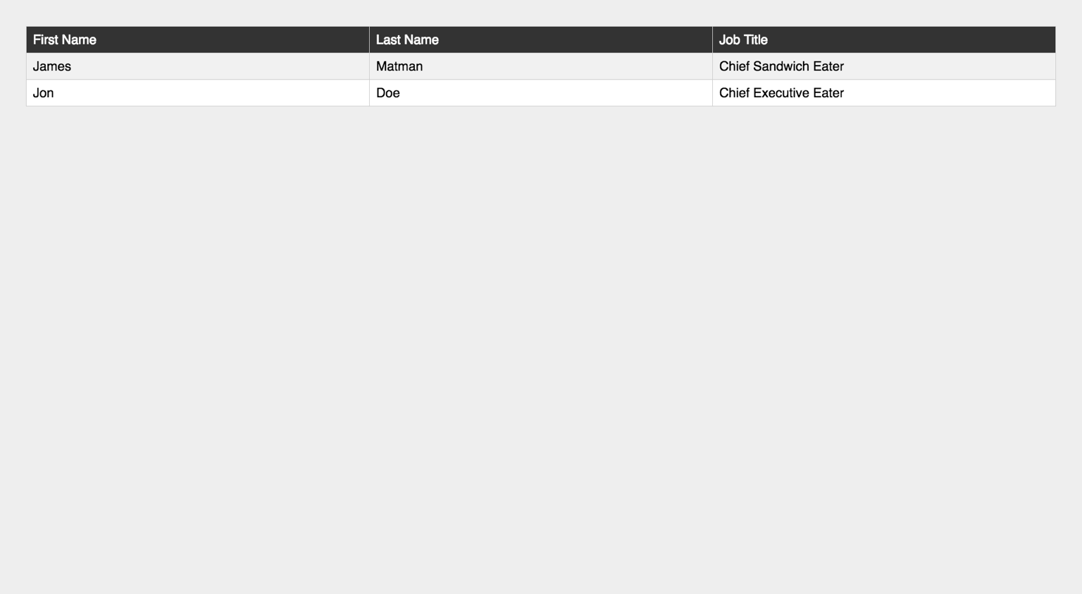

* Look at the provided screenshots in **resources** **folder** for different screen sizes view

### Requirements

* Change the document title to "**Responsive Tables**"
* Create a table with 3 columns: First Name, Last Name, Job Title
* Get the latest reset.css
* Get the latest typography.css
* Make the table **responsive**

## Responsive Vertical Timeline

Create a web page like the following:

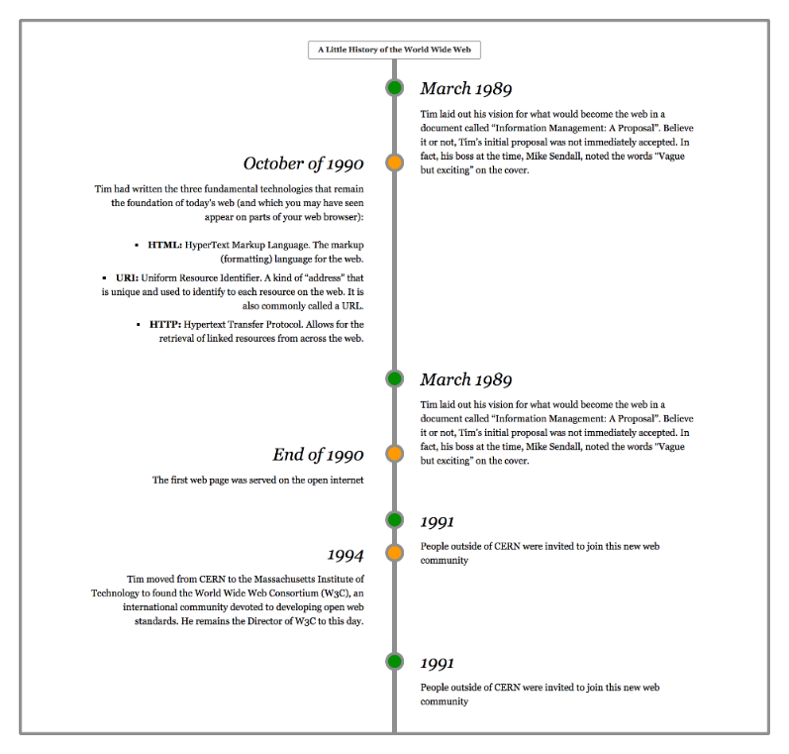

* Look at the provided screenshots in **resources** **folder** for different screen sizes view

### Requirements

* Change the document title to "**Responsive Vertical Timeline**"
* Create a section with class timeline
  + The section must have
    - Border width - 0.3rem
    - Border color - rgb(153, 153, 153)
    - Border style - solid
* Create seven articles (article) in the section
  + Divide **article content** into header and section
  + The header has h3 heading and the section has a paragraph with text inside
  + Style h3 font to italic
* Add media queries for the list to look good on **mobile** and **desktop**

## Company Web Site

You are **given** a company web site as **HTML**. Write the **missing** **styles**, to make the site look like this:

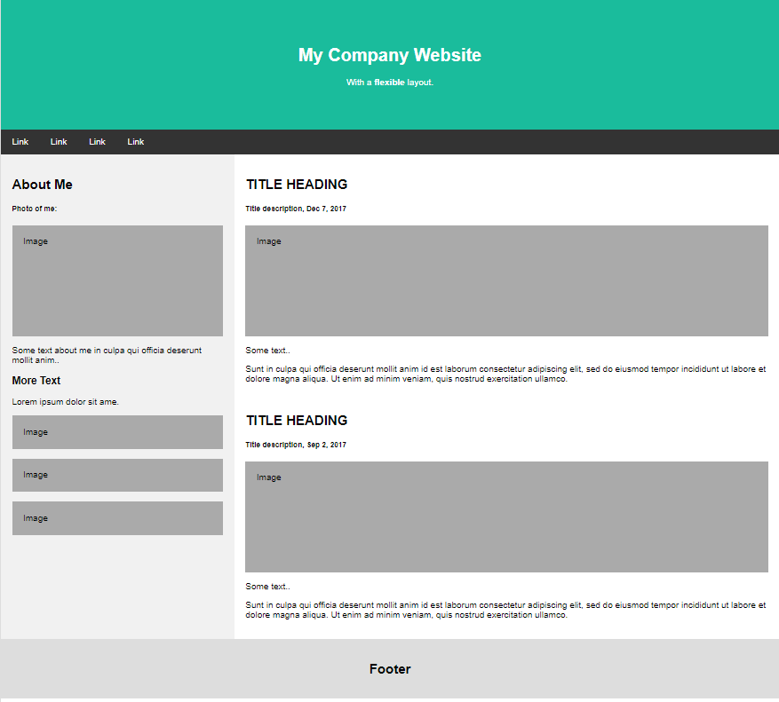

Ensure the site behaves correctly on small screens:

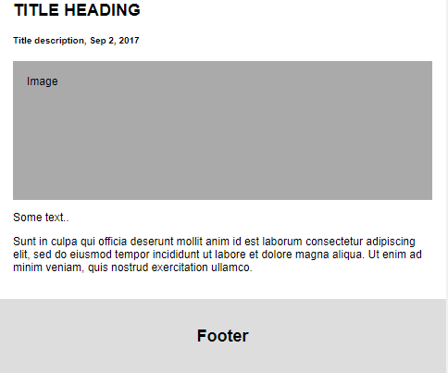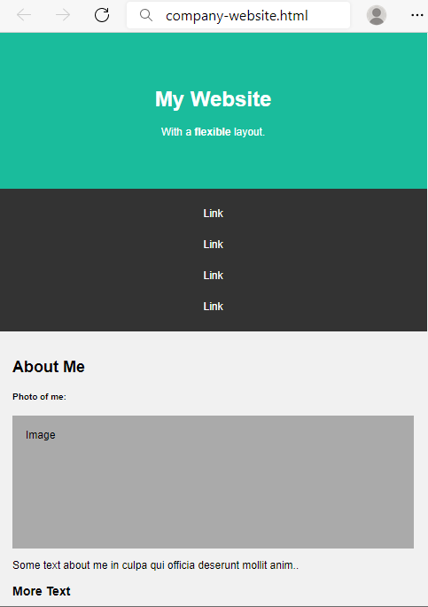 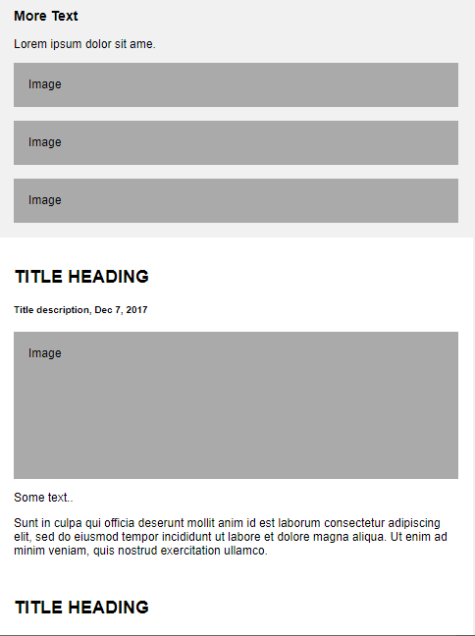

### Styles

* body
  + Margin: 0px
  + Font family: Arial
* header
  + Center the text
  + Padding: 60px
  + Margin: 0px
  + Background color: #1abc9c
  + Text color: white
* nav
  + Background color: #333
  + Top and bottom padding: 14px and 26px from left and right
* nav a
  + Text color: white
  + Top and bottom padding 14px and 20px from left and right
  + Align the text to left
  + Remove the text decoration
* aside
  + Background color: #f1f1f1
  + Padding: 20px
* main
  + Background color: white
  + Padding: 20px
* footer
  + Center the text
  + Padding: 20px
  + Background color: #ddd

### CSS Media Queries

To make the layout responsive, you need **two** **media** **queries**.

The **first** **query** concerns the rearrangement of the body**.** If the screen is **smaller** **than** 700px, display the body as block and set **the elements one after another**.

The second query concerns the style of the navigation bar. If the screen is smaller than 700px, display the <a> tag in the nav tag as block and center the text.